Complaint Handling Policy

Table of Contents
- Introduction 2
- Definitions/Acronyms 2
- References/Associated Documents 3
- Responsibilities 4
- Procedure 5
- Summary of Changes 7

- Introduction
  - Purpose
The purpose of this procedure is to establish the policy for handling customer complaints regarding LGC Bio Search Technologies products/materials.
  - Scope
This procedure applies to all LGC Bio Search Technologies products/material that have been released for sale.
- Definition/Acronyms
  - Advisory Notice - Documentation sent to customers and distributors which advises of a potentially hazardous situation or other less serious issues regarding non‐ conforming products and informs customers of necessary actions which must be taken to resolve the situation (see SOP-203438 Product Recall / Advisory Notice Procedure).
  - CAPA – Corrective Action and Preventative Action
  - CMO – Contract Manufacturing Organization that has responsibility to provide product to specifications that could undergo final review and release through GMPCS
  - Complaint – Any written, electronic, or oral communication from any source that alleges deficiencies related to the identity, quality, durability, reliability, usability, safety, effectiveness, or performance of an LGC marketed product after it is released for commercial distribution or an issue associated with the complaint process itself.
  - Complaint Files – All documentation related to a complaint. This documentation may include customer electronic communications, notes of customer or distributor oral conversations, and results of investigations.
  - CSI – Customer Service Incident; how complaints/feedback is documented in the system.
  - Feedback – The monitoring of gathered information relating to whether the organization has met the customer requirements. The documented feedback regards administrative service-related issues and can be distinguished as positive or negative. Examples include: Shipment and delivery performance, service management and capability, data/order entry performance, corrective action response time, or issues related to R & D or pre-commercially released products.
  - Inquiry – A request for information or guidance regarding product design or use. As inquiry does not constitute a complaint.
  - Investigation – A process for determining the cause of a problem in which the customer has indicated that the product/material has failed to perform as expected. An investigation may include, but is not limited to, a review of relevant documentation, testing of retained samples, testing of product returned by the customer and external parties outside the organization.
  - MDR – Medical Device Report. This is required for any reportable events, as described in SOP-203439 Medical Device Reporting (MDR) Procedure.
  - Medical Device Vigilance System and Post Markey Surveillance – System by which manufacturer notifies Competent Authorities of any malfunction or deterioration in the characteristics or performance of a device, or inadequacy of IFU or labelling which might lead to patient harm, or any issues resulting in systematic recall of devices. This applies to CE-marked IVD products.
  - Recall – An action which may be taken by Bio Search Technologies, Inc. if nonconforming or potentially hazardous product must be removed from the market, corrected or returned to Bio Search Technologies, Inc. for destruction, re‐labeling, or rework (see SOP-203438 Product Recall / Advisory Notice Procedure).
  - Resolution – A complaint is considered resolved only when the required investigation is completed, and any necessary corrective and/or preventative actions have been initiated.
  - Root Cause Analysis – An investigational problem-solving method aimed at identifying the causes of customer complaints. Analysis is performed systematically, with conclusions supported by documented evidence.
  - SCAR – Supplier Corrective Action Request (or any other formal customer request for corrective action)
- References/Associated Documents
  - References
    - 21 CFR Part 820, Medical Device; Current Good Manufacturing Practice (cGMP) Final Rule; Quality System Regulation, Food and Drug Administration, Federal Register.
    - ISO 9001, Quality management systems -Requirements, International Organization for Standardization.
    - ISO 13485, Medical Devices – Quality Management Systems – Requirements for Regulatory Purposes, International Organization for Standardization.
    - ISO 14971, Medical Devices – Application of Risk Management to Medical Devices, International Organization for Standardization.
    - Medical Devices Directive (Article 10 and Annexes II, IV, V, VI, VII)
    - In Vitro Diagnostic Directive (IVDD)
  - Associated Documents
    - FM-203727.01 GMPCS Product Complaint Form
    - WI-203727.03 Complaint Handling Work Instructions
    - WI-203727.04 Complaint Handling Work Instructions GMPCS
    - SOP-201900 Corrective Action and Preventative Action (CAPA) Policy
    - SOP-203397 Record Retention Policy
    - SOP-203438 Product Recall / Advisory Notice Procedure
    - SOP-203439 Medical Device Reporting (MDR) Procedure
    - SOP-209756 Investigation Guidelines
    - FM-209756.01 Investigation Report Form
    - WI-209944 Use of the Customer Service Incident GMPCS Manufacturing Investigation Form
    - FM-209944.01 Customer Service Incident Manufacturing Investigation Form
- Responsibilities
  - All Employees
    - Responsible for forwarding any customer communications regarding complaints to QA if it has not already been received by customer service or technical support.
  - Customer Service
    - Responsible for evaluating non-technical administrative customer inquiries for escalation to a customer complaint.
    - Responsible for receiving customer calls and routing them, as appropriate, to Technical Support or Quality Assurance Management.
    - Responsible for forwarding any customer inquiry alleging deficiency of a product manufactured by the GMPCS or Hybrid Production groups to Technical Support according to WI-203727.04.
    - Responsible for resolving and documenting non-technical administrative customer complaints according to WI-203727.03.
  - Technical Support
    - Responsible for resolving and documenting technical chemical or custom oligonucleotide related customer complaints according to WI-203727.03.
    - Responsible for forwarding any customer inquiry alleging deficiency of product manufactured by the GMPCS or Hybrid Production groups to Quality Assurance Management according to WI-203727.04.
    - Responsible for evaluating customer inquiries for escalation to a customer complaint or feedback.
    - Responsible for documenting customer complaints in real time as a Customer Service Incident in FileMaker Pro.
    - Responsible for coordinating an investigation into a customer complaint.
    - Responsible for working with Quality Assurance Management to determine any corrective and/or preventative actions resulting from the customer’s complaint.
  - GMPCS Production Management
    - Responsible for coordinating an investigation into a GMPCS and Hybrid product customer complaint according to WI-203727.04.
    - Responsible for communicating resolution of a GMPCS and Hybrid product complaint to the customer.
    - Responsible for working with Quality Assurance Management to determine any corrective and/or preventative actions resulting from the customer.
  - Quality Assurance
    - Responsible for evaluating all GMPCS and Hybrid product customer complaints for Medical Device Reporting, Vigilance Reporting, Advisory Notice and/or Product Recall needs.
    - Responsible for working with Technical Support and/or GMPCS Production Management to determine appropriate corrective actions and/or preventative actions that need to be opened because of a customer complaint and handling those actions according to the requirements of SOP-201900 Corrective Action and Preventative Action (CAPA) Policy. A CAPA must be opened when a SCAR is sent to us.
    - Responsible for holding review board meetings a minimum of once per month and inviting site specific operations representatives to the meetings.
    - Responsible for verifying the completeness of complaint files and closing CSIs for GMPCS and Hybrid product according to WI-203727.04.
  - Regulatory Affairs
    - 4.6.1. Assessing complaints for Medical Device Reporting, Vigilance Reporting, Advisory Notice and/or Product Recall needs.

- Procedure
When an LGC Bio Search Technologies employee receives a customer communication that may or may not be considered a complaint according to the definition in section 2 of this document, the communication shall be forwarded to Technical Support as soon as practically possible.

  - Technical Support or Customer Service shall contact the customer to acknowledge receipt of the complaint within 48 hours and to gather general information, including a description of the issue and product identification. This information shall be captured in real time in the Customer Service Incident database in File Maker Pro. If the customer is contacted at least 3 times to obtain more information around the complaint and no information is provided, the issue will be closed out with a justification that the customer was contacted at least 3 times with no response will be stated.
    - Regulatory Affairs/Quality Assurance will assess the complaint for Medical Device Reporting, Vigilance Reporting, Advisory Notice and/or Product Recall needs.
    - See WI-203727.03 Complaint Handling Work Instructions and WI-203727.04 Complaint Handling Work Instructions GMPCS for detailed directions on entering communications into File Maker Pro.
    - See WI-209944 Use of the Customer Service Incident Manufacturing Investigation Form for instructions on filling out FM-209944.01 Customer Service Incident Manufacturing Investigation Form during investigations for GMPCS manufacturing operations.
    - For complaints associated with Chem Production and/or Custom Oligonucleotide Production, WI-203727.03 shall be followed.
    - For non-technical administrative complaints, WI-203727.03 shall be followed.
    - For GMPCS/Hybrid product complaints, WI-203727.04 Complaint Handling Work Instructions GMPCS, shall be followed.
    - If a customer initiates SCAR as a part of the complaint, a CAPA is required to be initiated by SOP-201900.
    - Retention of Complaint Files
      - Complaint records shall be maintained according to the requirements of SOP-203397 Record Retention Policy.
  - Review Board
    - There will be at a minimum, a monthly CSI review board established to review all open CSIs and discuss necessary steps for resolution. The board will consist of site-specific operations representatives.
      - Customer complaint investigations shall be completed as promptly as possible with the goal of completing the investigation within 30 days of receipt of the complaint. If the investigation is not closed within this timeframe, updates as to the status of the investigation shall be communicated during review board updates until the investigation is complete and the complaint is closed out. If CAPA has been initiated, then the complaint investigation can be considered closed if the CAPA number is referenced.
  - Process Diagram

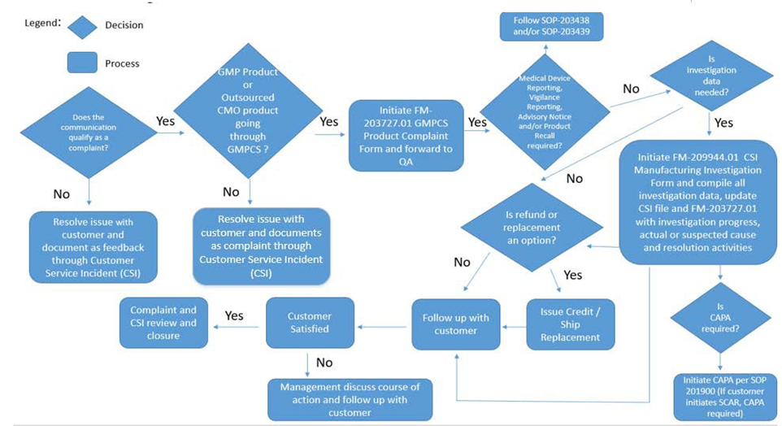

- Summary of Changes
Revision | Description of Change | CRR No.
7.0 | Removed Therapeutics from the scope of this procedure. Updated references to include newly created Investigation Procedure. | 2020-0155
8.0 | Updated Complaint and Feedback Definitions, Added CSI, CMO, Medical Device Vigilance Reporting and Post Market Surveillance to definitions; Added WI-209944 and FM-209944.01 to references as these documents clarify the complaint investigation process for GMPCS; Added Medical Device Directive and IVDD to references; Added requirement to notify customer of receipt of issue within 48 hours and statement that an issue can be closed out if the customer is notified at least 3 times with no response; Added monthly requirement for CSI review board and removed specific stakeholders as this list will change depending on the complaint; Deleted old flow chart and added updated flow chart; Added definition for SCAR and that a CAPA must be opened when a customer submits a SCAR; Added Regulatory Affairs to responsibility section | 2020-1132
9.0 | Added section 4.1.1 for including QA on customer complaints when not received by customer service or technical support; Added references to Hybrid RUO/GMPCS Products throughout document. Deleted old flow chart and added updated flow chart. | 2021-0292
10.0 | Refined the definition of CSI resolution and closure to reflect current practices. | 2021-0440

